|  |
| --- |
| csc  6/17/2023 |

|  |
| --- |
| CSC PALLAVARAM |
| HTML |
| SUBMITTED BY YUVAN |

Contents

STRUCTURE OF HTML ; 3

HEADING TAG ; 4

PRE & PARA TAG 5

STYLE TAG 6

DIV TAG AND ASIDE TAG 7

IMG TAG 8

MARQUEE TAG 9

LIST TAG 10

ACHOR TAG 11

TABLE TAG 1 12

INPUT TAG 13

VIDEO TAG 14

AUDIO TAG 15

QUOTATION TAG 16

SPELL CHECK TAG 17

COLOR STYLE &HSL 18

GEO LOCATION TAG 19

DRAG AND DROP 20

LAYOUT AND SEMANTICS 21

**canvas – gradient** 22

**Canvas- shadow** 23

**Canvas-rotate** 24

**canvas-draw image** 25

EX.1

# STRUCTURE OF HTML ;

INPUT: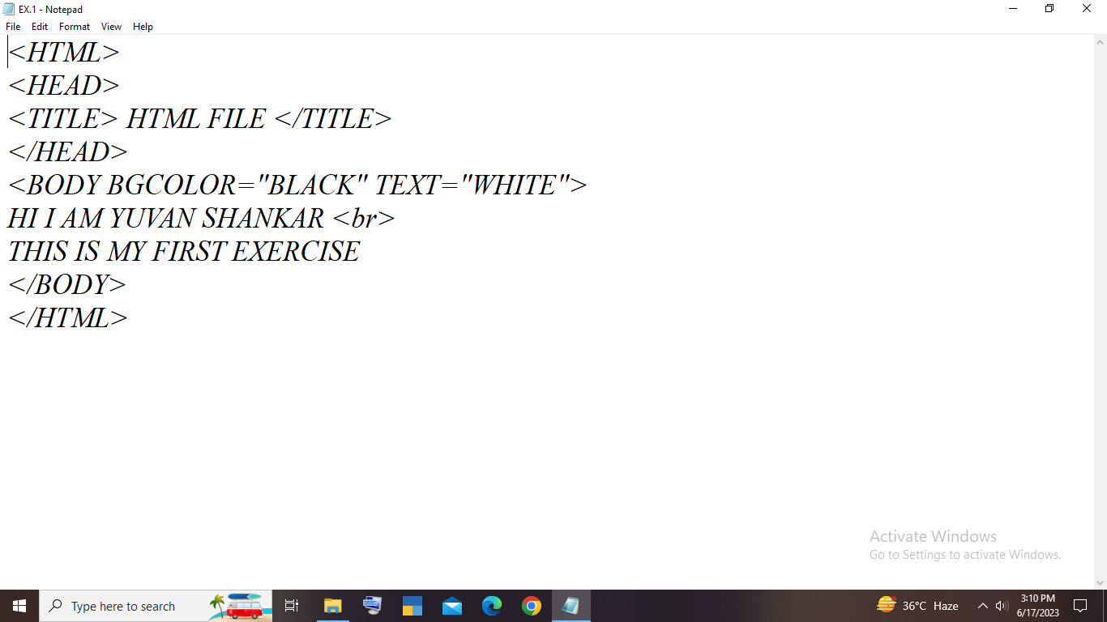

OUTPUT:

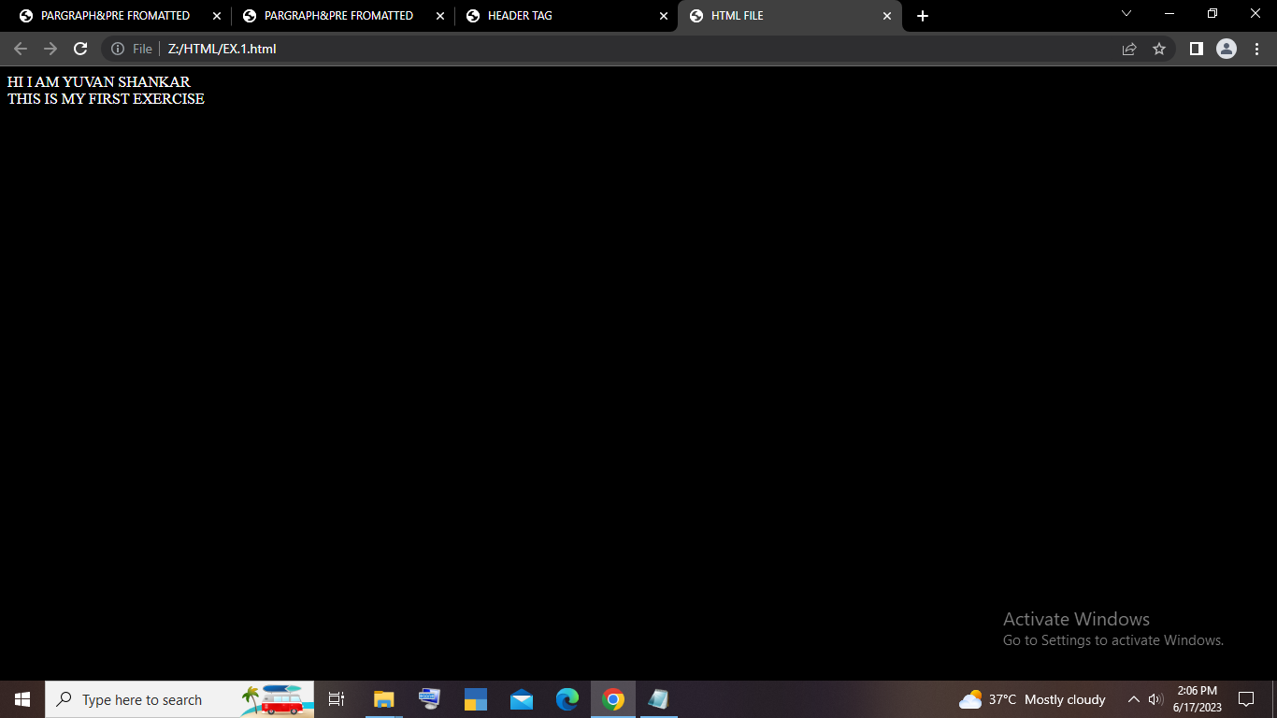

EX.2

# HEADING TAG ;

INPUT :

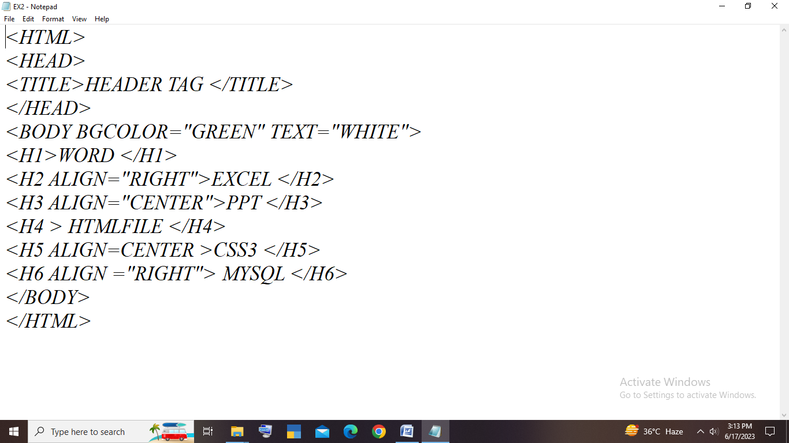

OUTPUT:

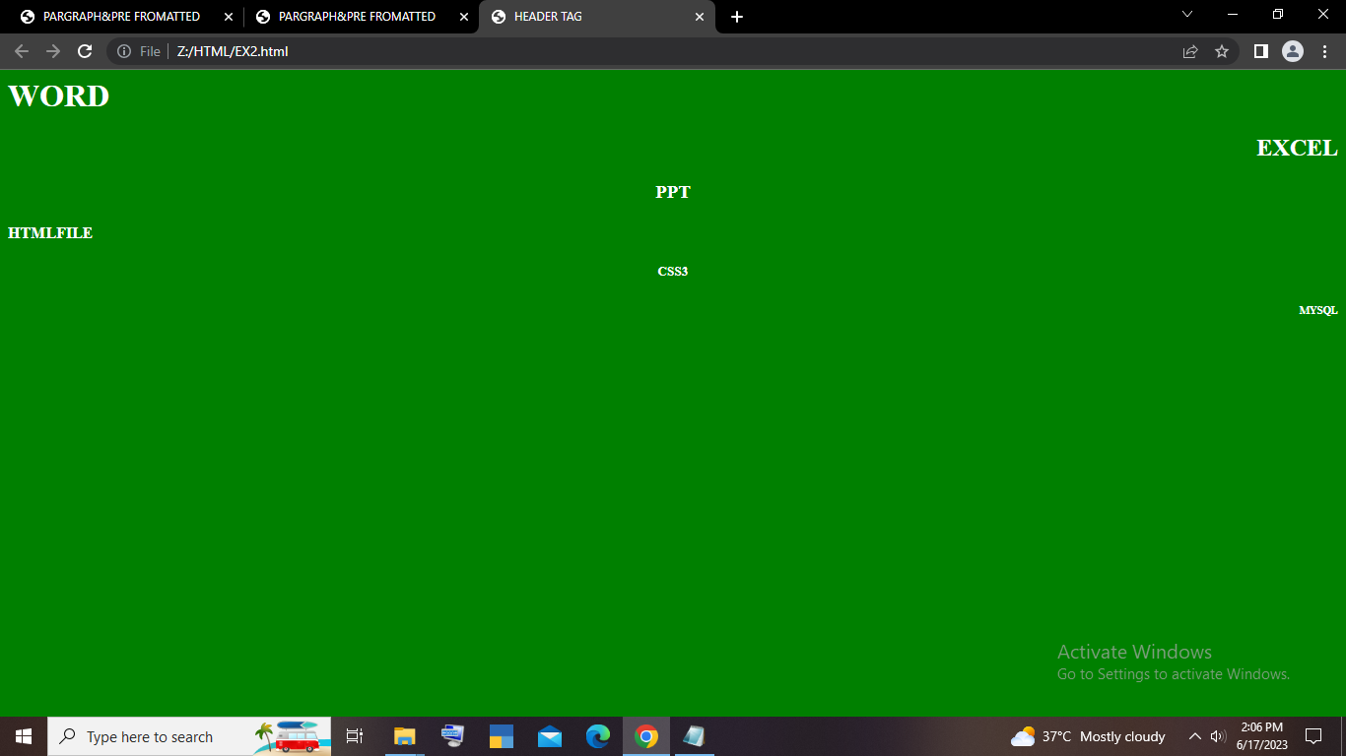

EX.3

# PRE & PARA TAG

INPUT:

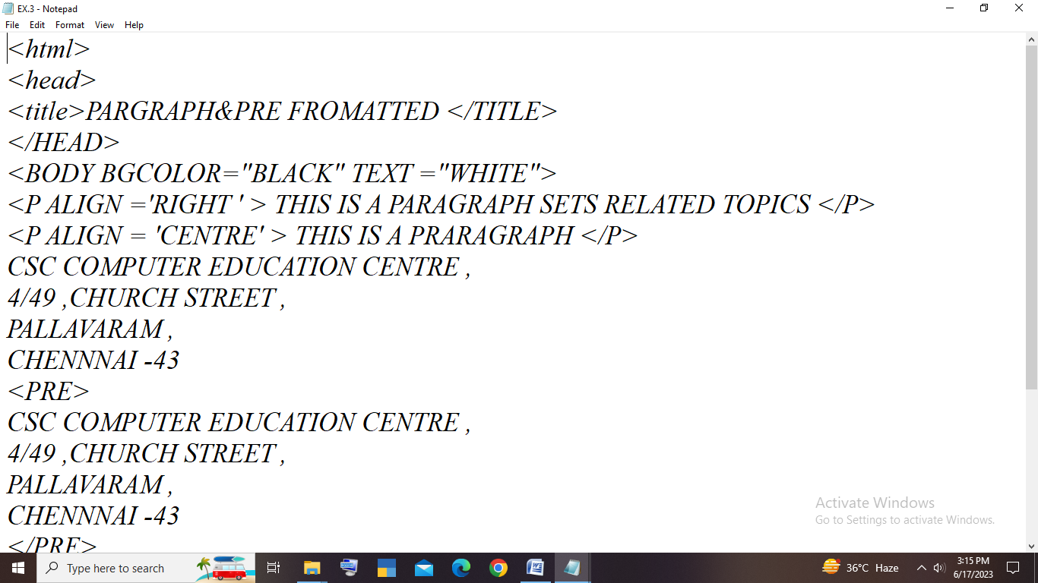

OUTPUT:

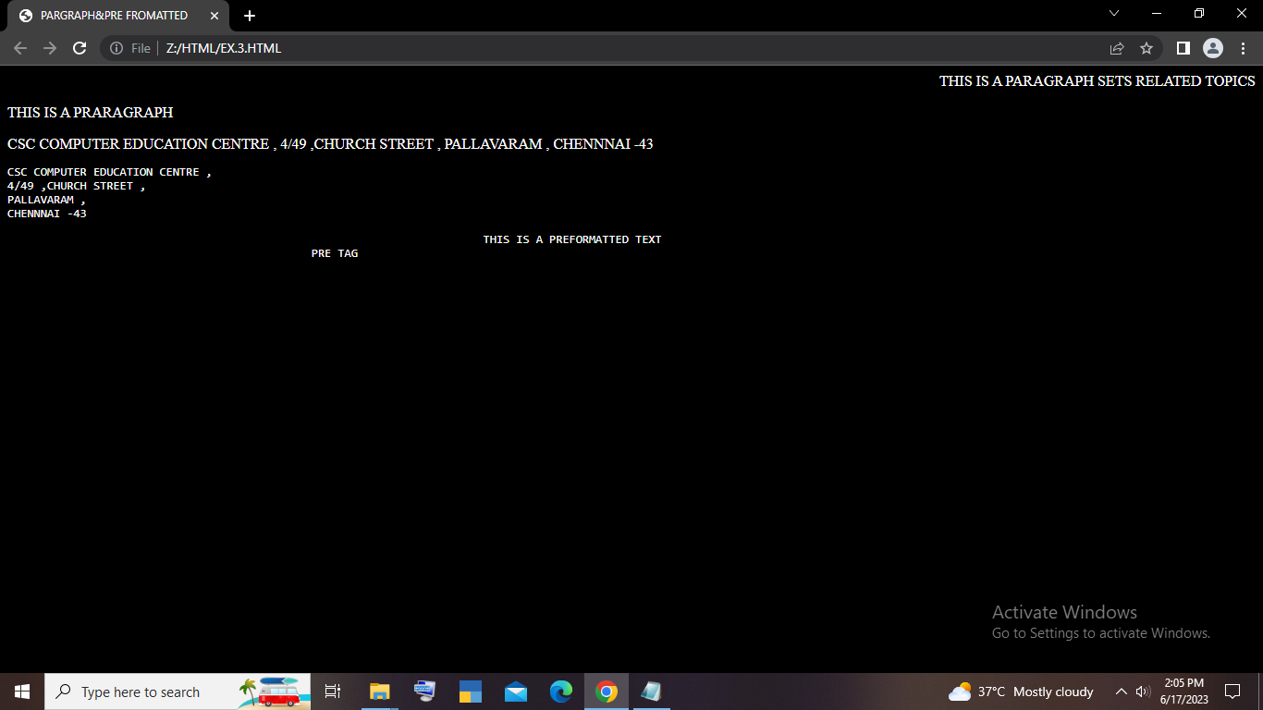

EX.4

# STYLE TAG

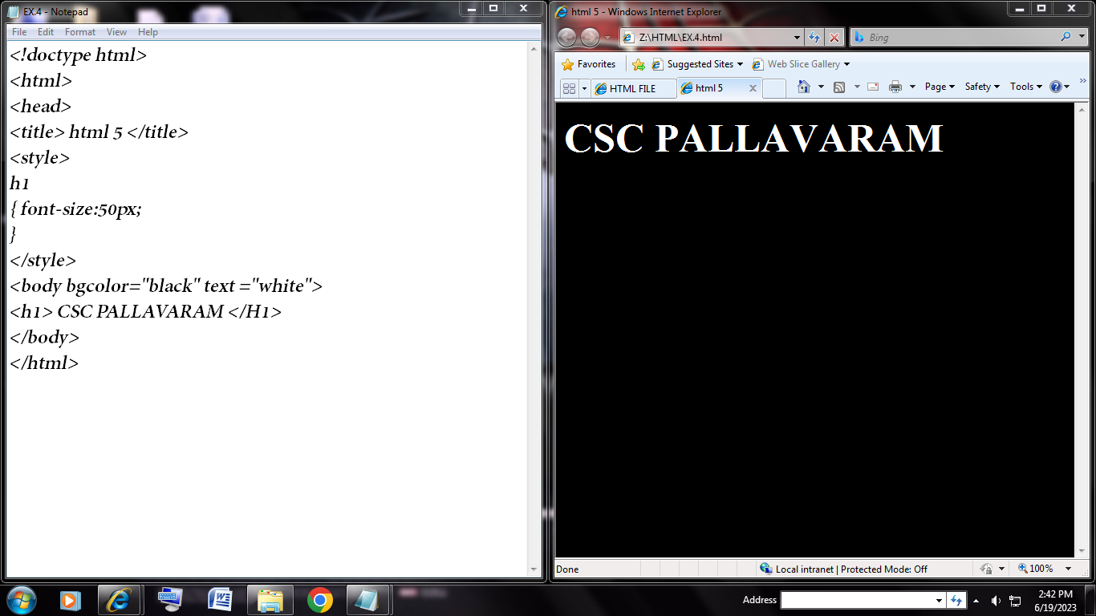

Hyperlink :[click here to go :)](EX.5.html)

EX.5

# DIV TAG AND ASIDE TAG

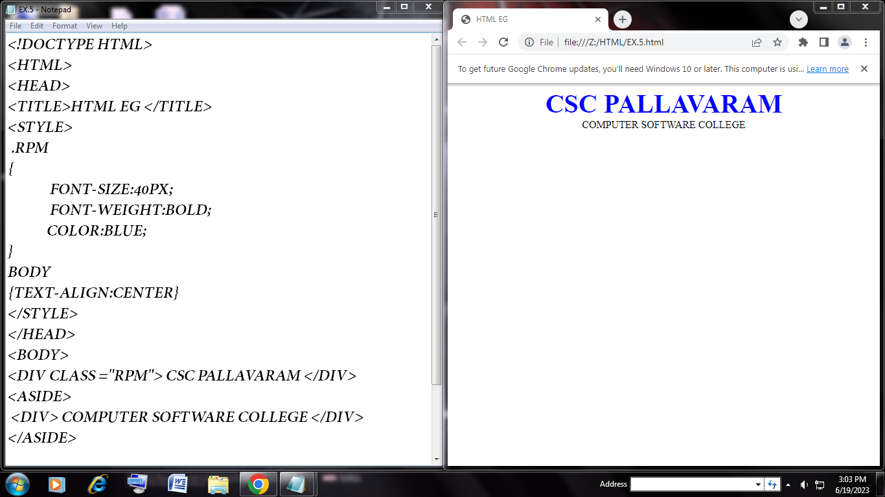

Hyperlink:[click here to go -> EX.5.html](EX.5.html)

Ex.6

# IMG TAG

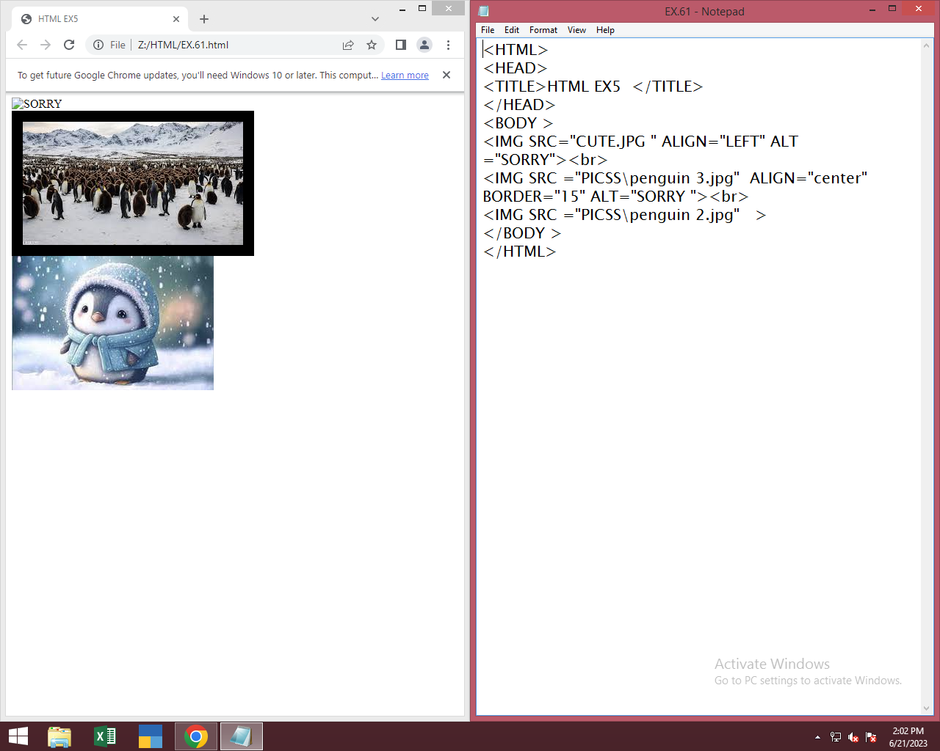

Hyperlink :[click here to go -> ex 6](EX.61.html)

Ex.7:

# MARQUEE TAG

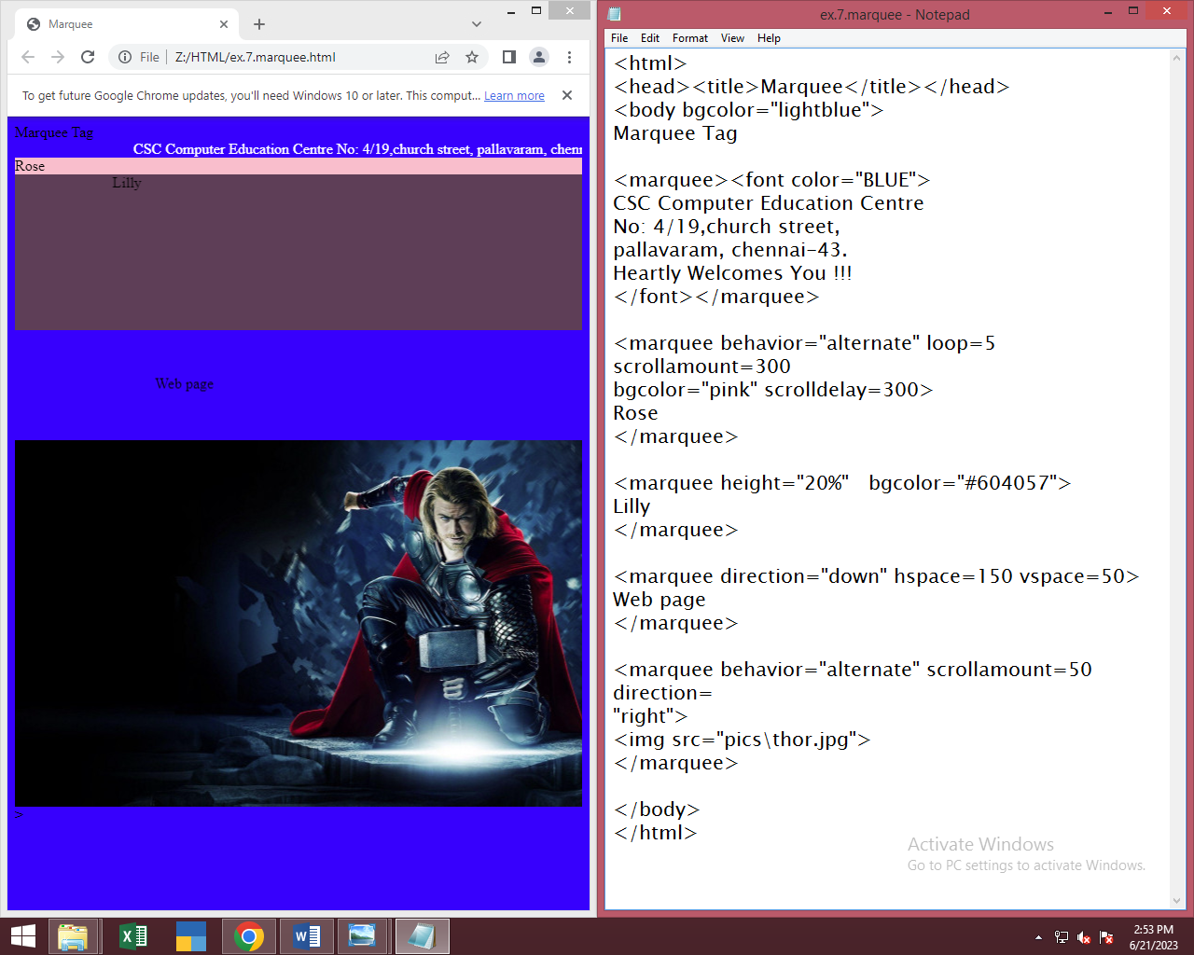

Hyperlink :[click here to go](ex.7.marquee.html)

EX.8

# LIST TAG

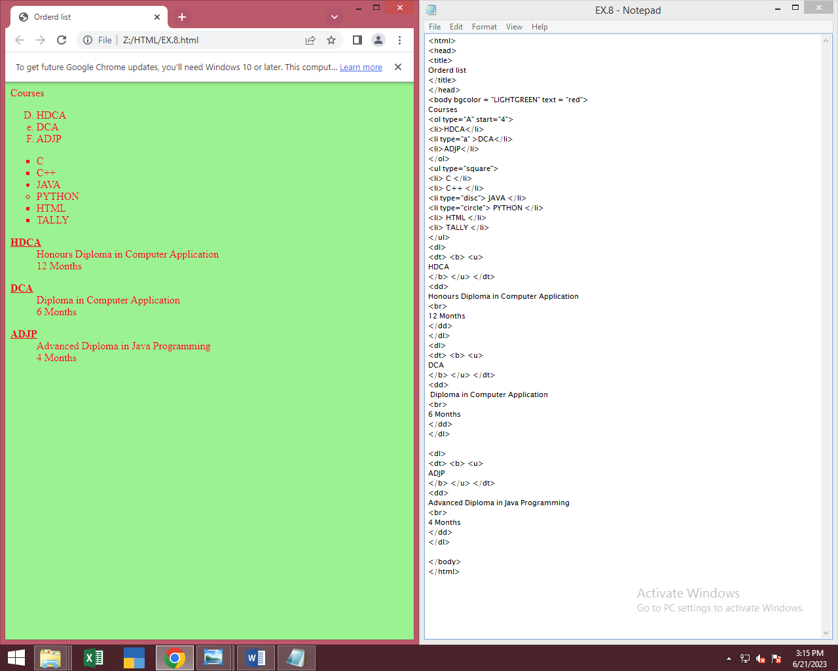

**Hyperlink:** [**EX.8.html**](EX.8.html)

EX.9

# ACHOR TAG

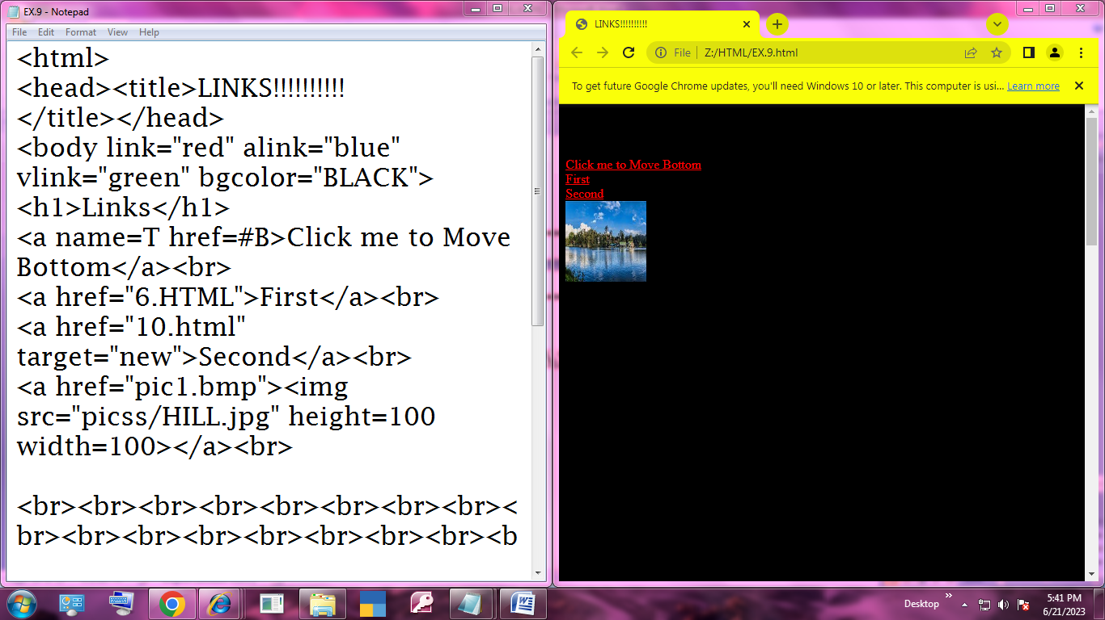

**Hyperlink:** [**EX.9.html**](EX.9.html)

Ex.10

# TABLE TAG 1

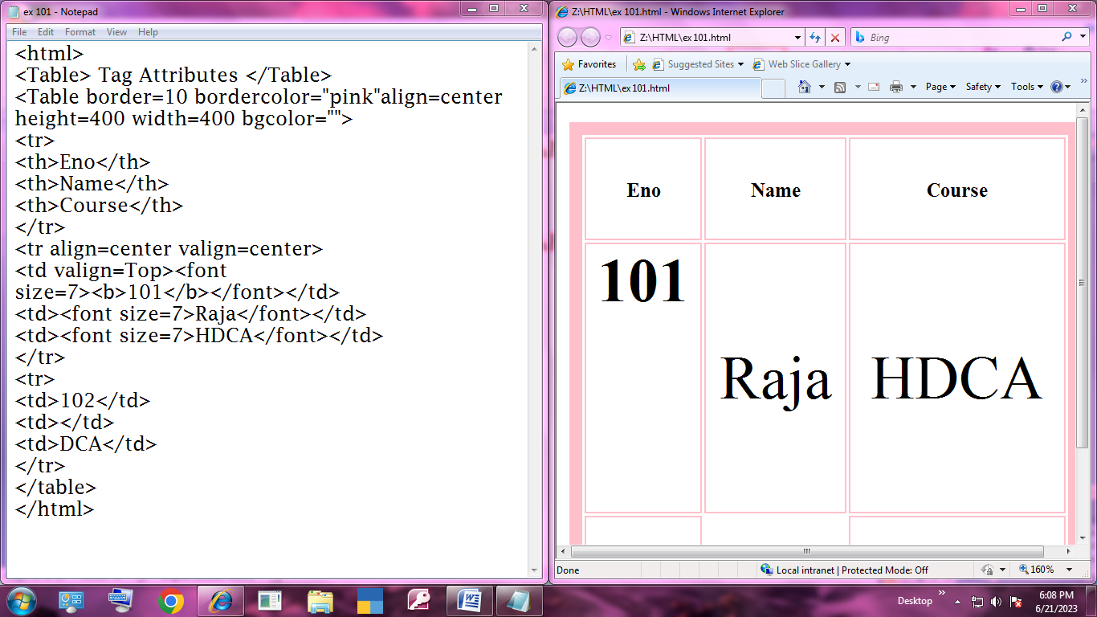

**Hyperlink:** [**ex 101.html**](ex%20101.html)

Ex.11

# INPUT TAG

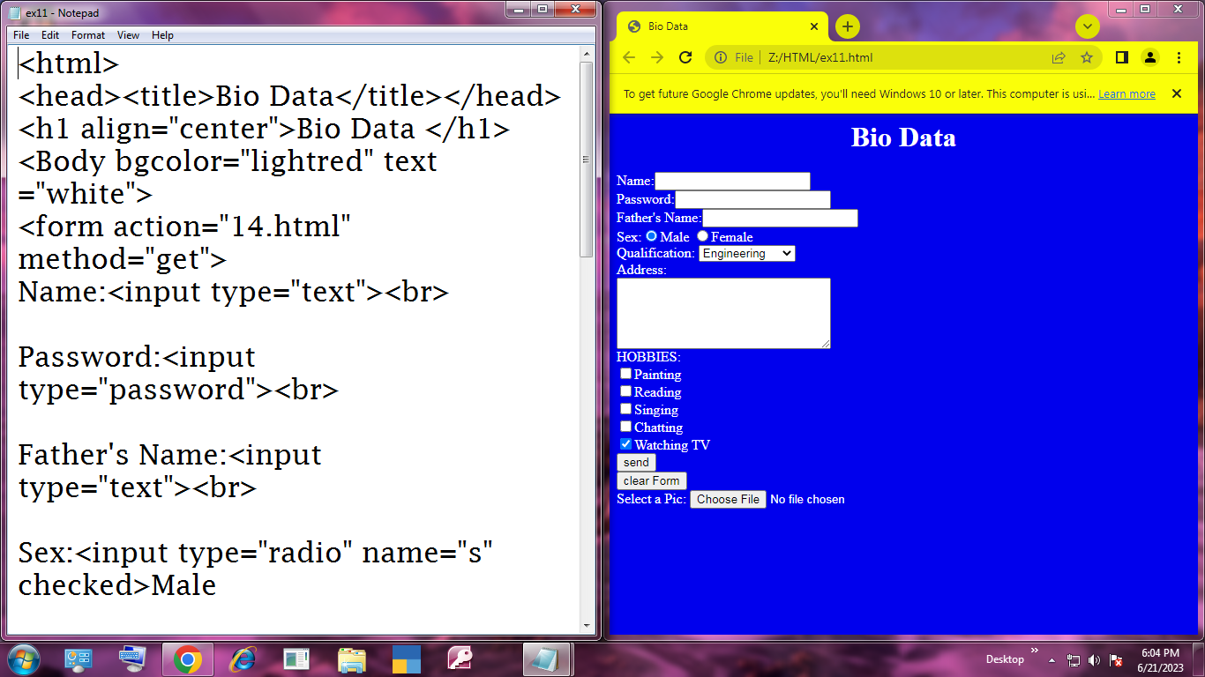

**Hyperlink :**[**ex11.html**](ex11.html)

Ex . 12

# VIDEO TAG

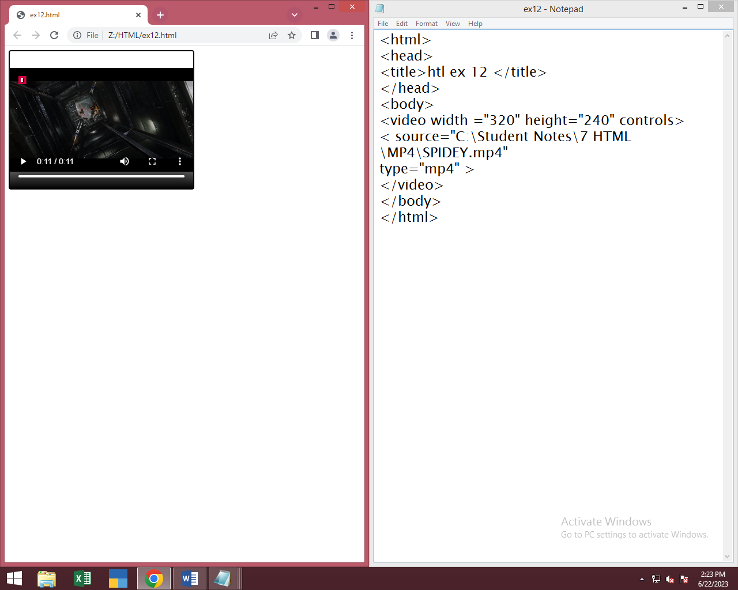

Ex13

# AUDIO TAG

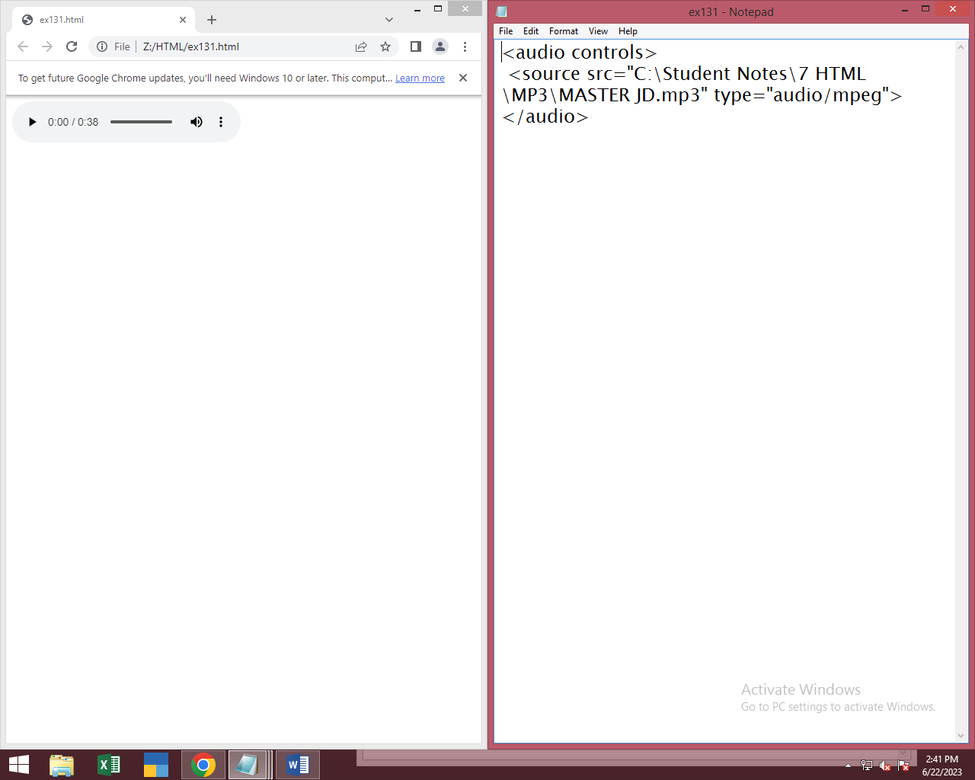

Ex.14

# QUOTATION TAG

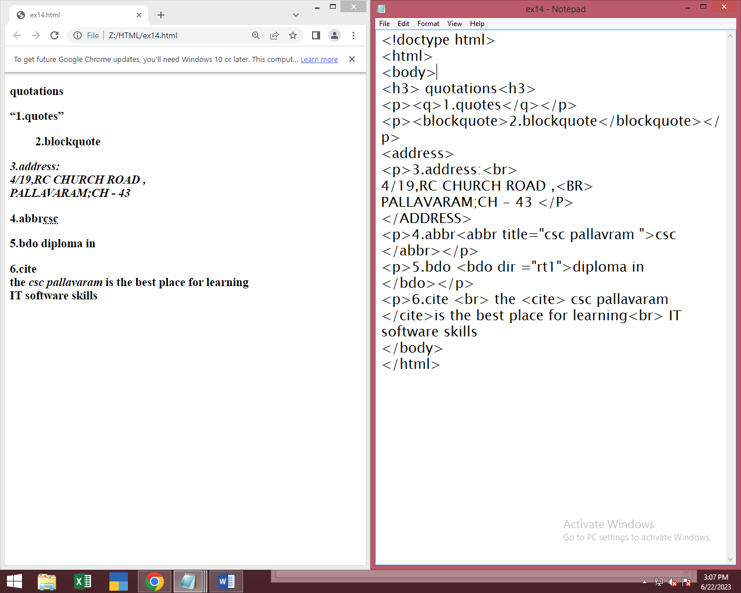

Ex. 15

# SPELL CHECK TAG

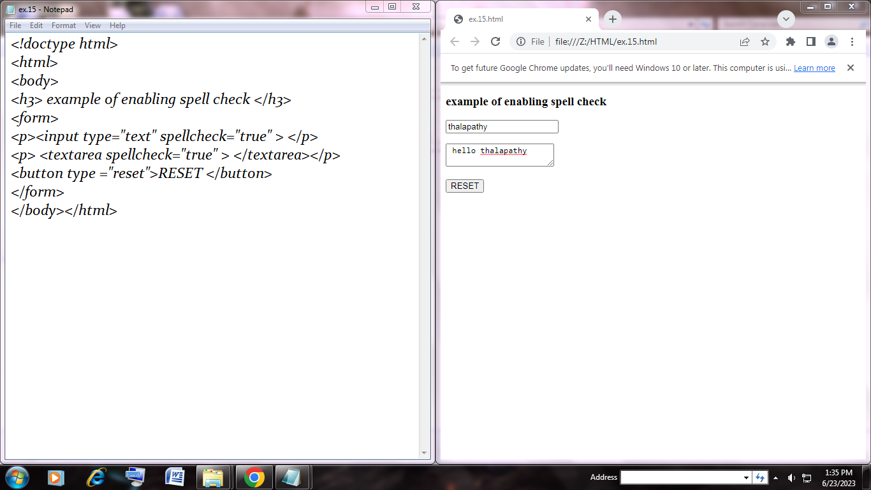

Ex.16

# COLOR STYLE &HSL

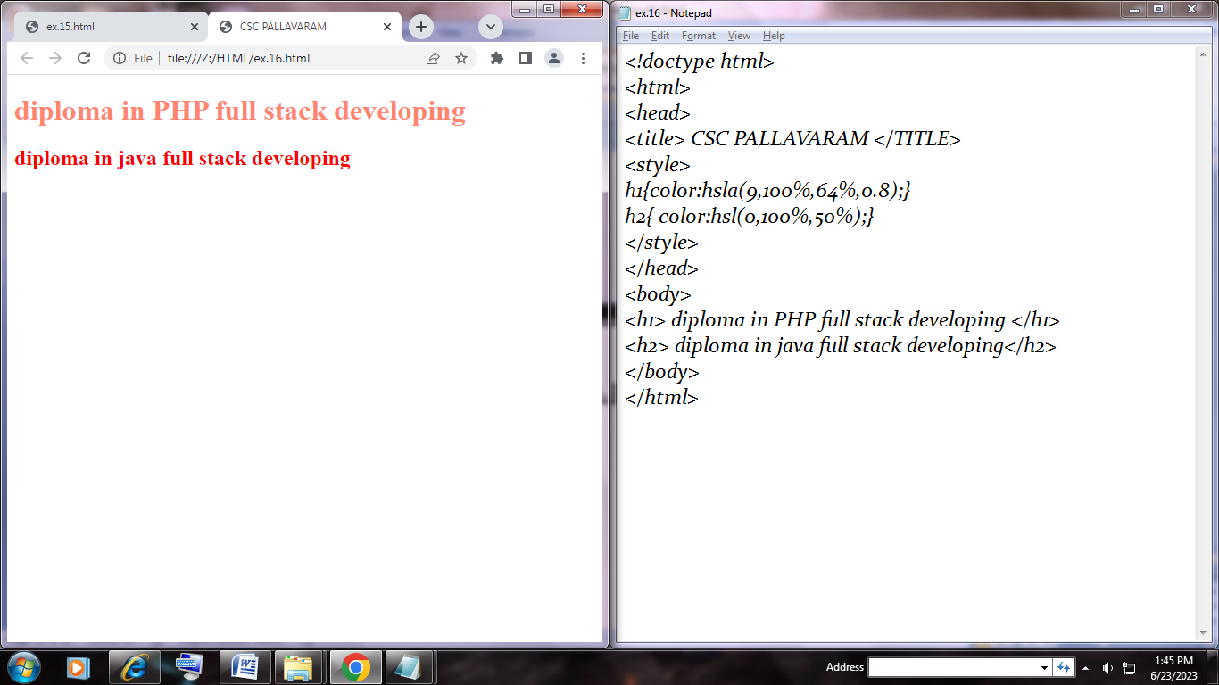

Ex.17

# GEO LOCATION TAG

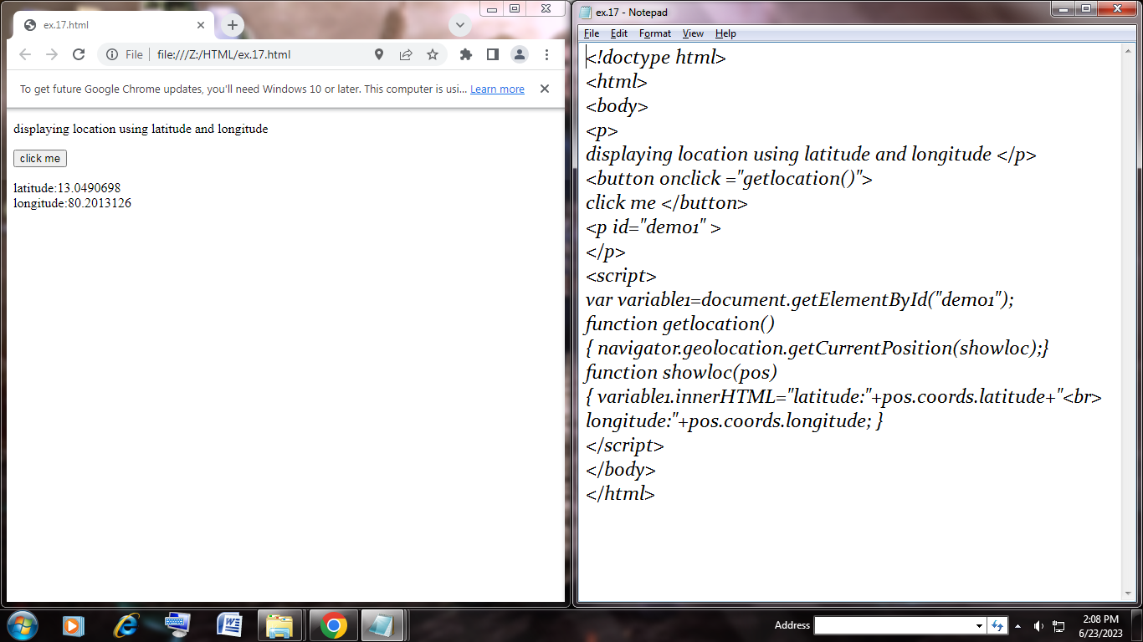

Ex.18

# DRAG AND DROP

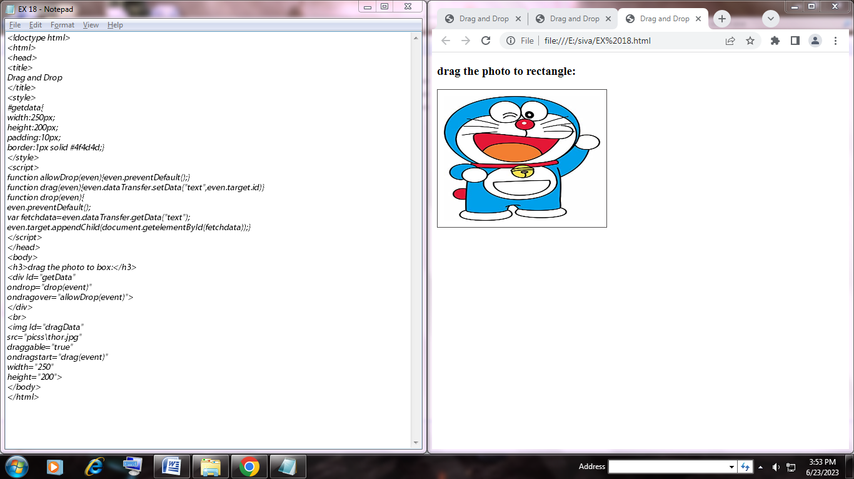

Ex.19

# LAYOUT AND SEMANTICS

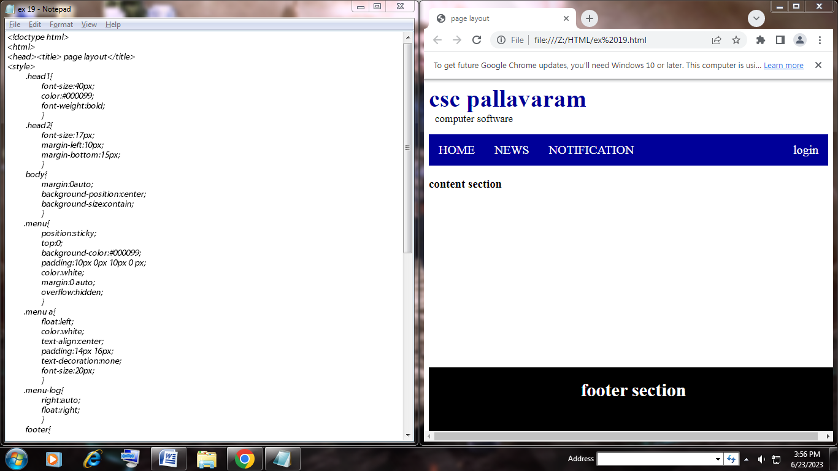

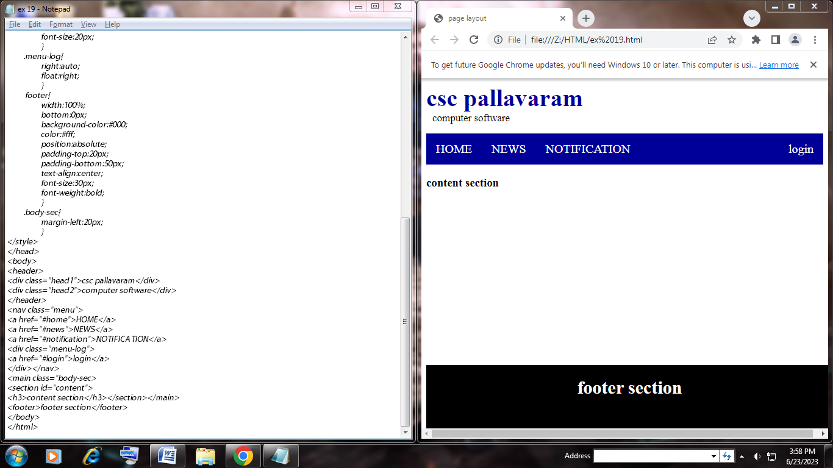

**Ex.20.1**

# **canvas – gradient**

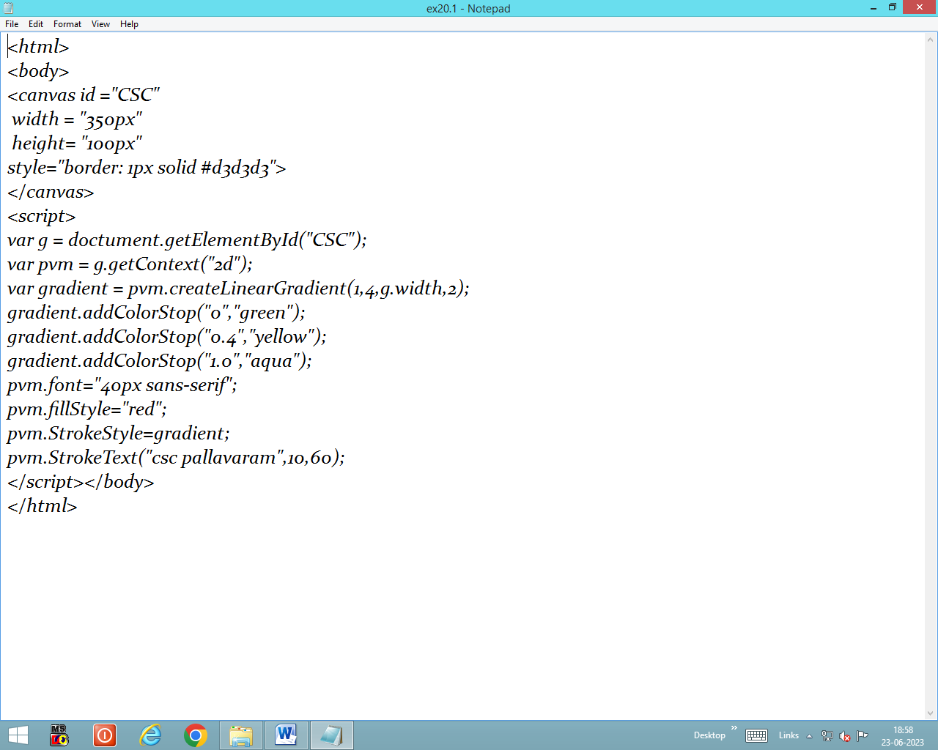

**Ex.20.2**

# **Canvas- shadow**

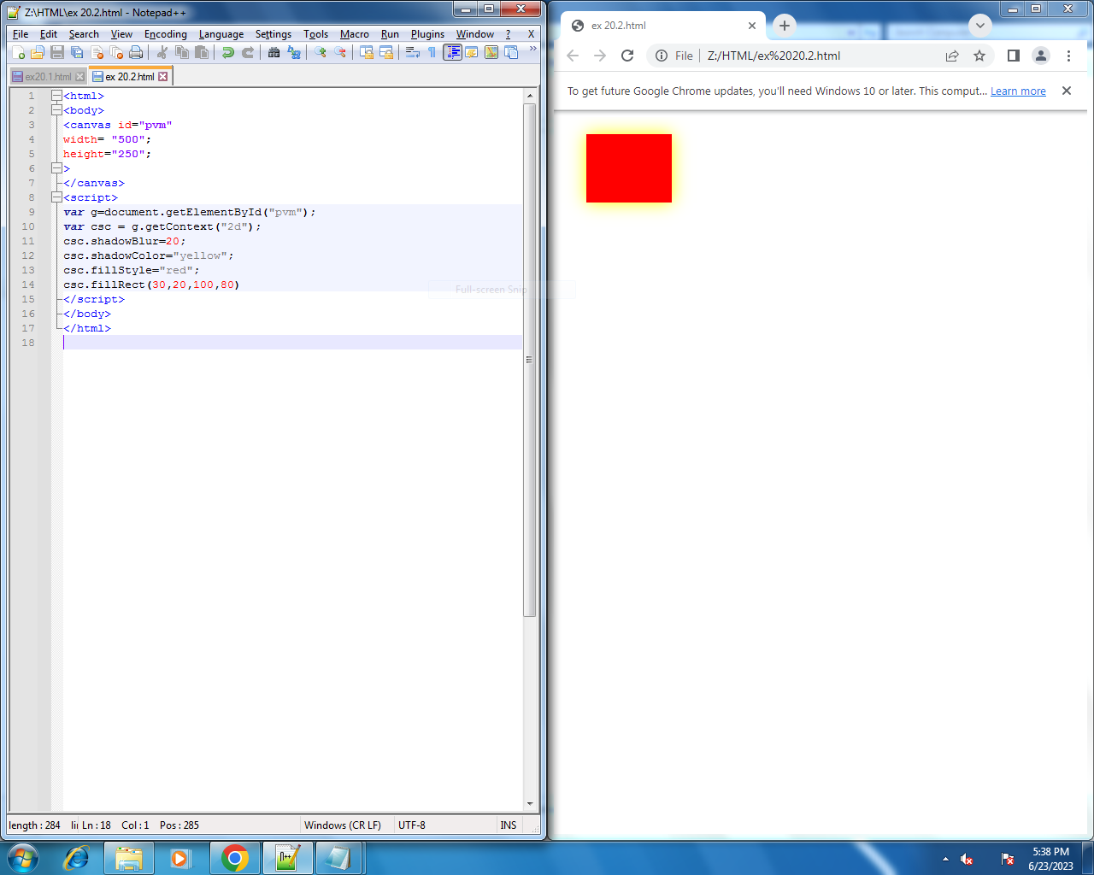

**Ex.20.3**

# **Canvas-rotate**

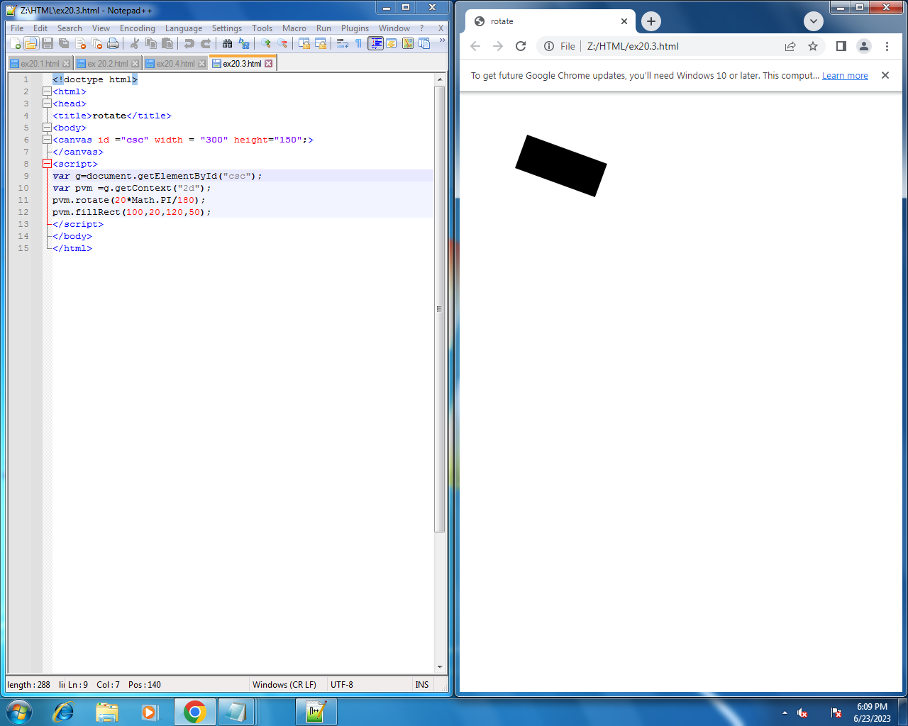

**Ex.20.4**

# **canvas-draw image**

